**OrthoEngine - Using Ancillary Data**

This tutorial steps through using GPS and INS ancillary data to automatically orthorectify raw digital aerials. It is assumed that you have prior experience with PCI OrthoEngine. If not please complete *OrthoEngine Training Tutorial - Basics v2* before undertaking this tutorial.

**GPS/INS data - WordPad/Excel**

This data is available from NGI on request. It takes the format of a text file with job metadata, format structure and the exterior orientation data for each aerial taken. The relevant data for the exterior orientation import file is the vertical coordinates (XY), the height (Z), and the Omega, Phi and Kappa (roll, tilt, yaw) of the sensor. Often the standard deviations of these factors are also available, and should be included. However, for this walkthrough we will only be working with XYZ and OPK.

Typical ancillary files are in txt format, and may look like this:

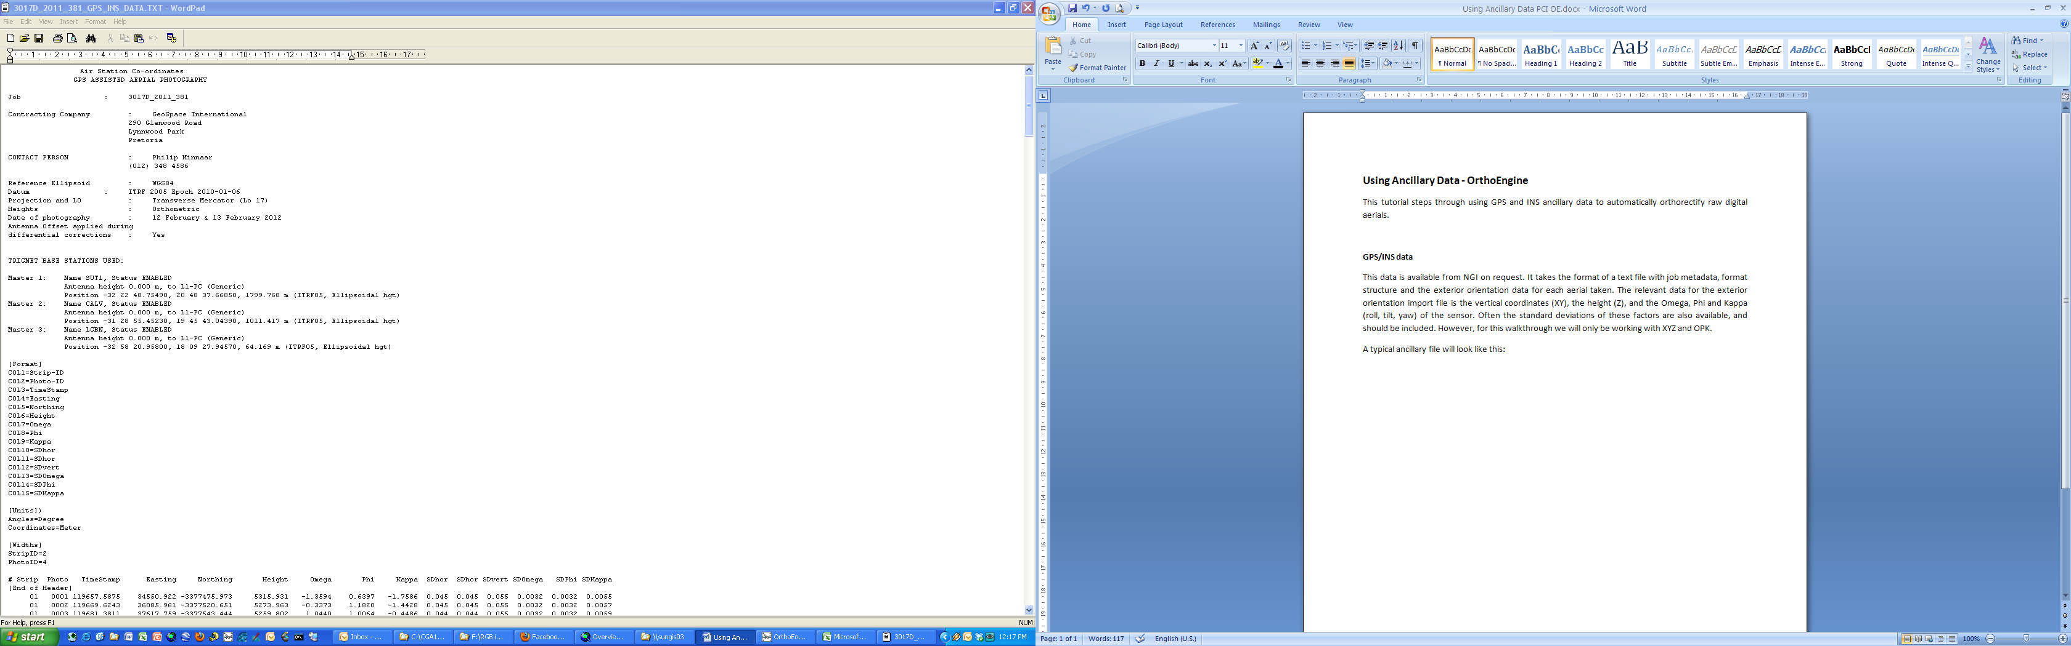

Further records

1. The first step is to save your file as <filename>_EDITED.txt
2. Remove the header, leaving only the data applicable to the images. This includes the heading of each column.
3. Save your file, close it in WordPad, and reopen it in Excel. You will have to specify the delimitation format - typically Space.
4. Move any unnecessary columns to the right of the file, ensuring the order is |X|Y|Z|O|P|K|etc.

You now need to reconstruct the raw image filenames e.g. 3017D_2011_381_01_0001_RGB. Two things to note here:

- Make sure to exclude the file extension e.g. .tif.

- Excel reads a number without the zeros, converting e.g. "0001" to "1". Use the following formula to add the required zeros:

=RIGHT(CONCATENATE("0000",TEXT(<*number*>,0)),<*digits*>)

where: *number* is the number you want formatted, and

*digits* is the number of digits you wish the number to be

To join the filename use this formula:

=CONCATENATE("<*stringhandle*>_",<*formattedstrip*>,"_",<*formattednumber*>,"_RGB")

1. Once you have reconstructed the filename, copy the relevant data, paste to a new sheet in excel (*paste special > values*), according to the following structure: FILENAME|X|Y|Z|O|P|K| e.g:

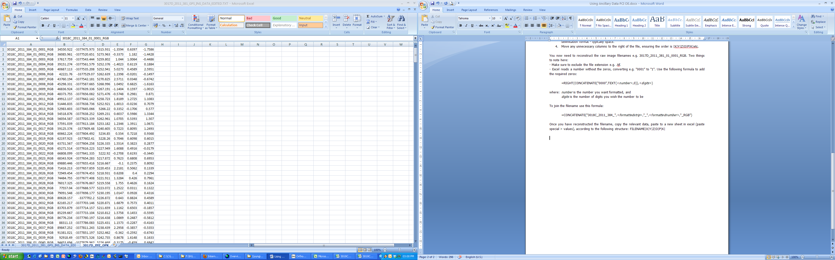

1. Save the file as a text file e.g. <FILENAME>_FORPCIIMPORT_XYZOPK.txt
2. In the original sheet, calculate the averages of each of the standard deviation columns of X, Y, Z, O, P, and K.
3. Save a copy of what you have done as an excel spreadsheet in case you need to make changes later.

**Project setup - OrthoEngine**

1. Open a new project in OrthoEngine and set it up as **Aerial Photography** > **Digital / Video**.
2. Define the projection of your output images and GCPs - preferably keep it the same as that of your GPS/INS data (usually the LO system in SA). Set your output pixel spacing as 0.5m.
3. Define the **Focal length** and **chip size** according to the calibration certificate e.g:

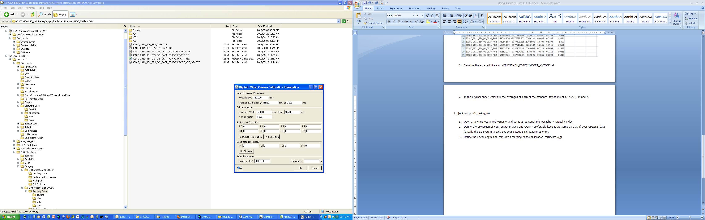

1. Under **Data Input**, enter all the images into the project that you wish to orthorectify (and that you have GPS/INS data for, obviously).
2. It is not necessary to change the orientation data of the raw images, if the kappa values in the ancillary data are correct. You can check this by comparing sequential strips. Since the aircraft usually flies in a back-and-forth pattern, adjacent strips usually have opposite orientation. If the kappa values match this e.g. +-0 vs +-180, image rotation is not necessary.
3. Click **Import exterior orientation data from a text file**.

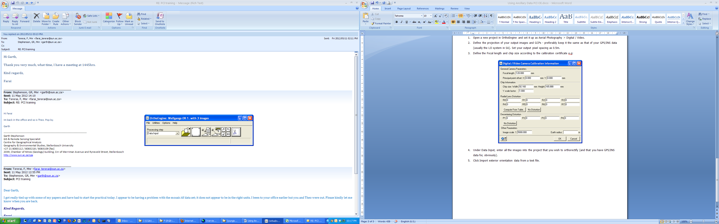

1. Click **Set Input Projection based on Output Projection**.
2. Ensure **Input angle unit** is set to **Degrees**.
3. Set the **File format** to **ImageID X Y Z Omega Phi Kappa**
4. Under **Accuracy**, enter the averaged values for the standard deviations of X, Y, Z, O, P, and K, which you calculated earlier.
5. Click Browse and locate your text file e.g. 3017D_2011_381_GPS_INS_DATA_FORPCIIMPORT_XYZ_OPK.TXT

Upon successfully loading your ancillary data file, Extracted Data should be populated with the exterior orientation file from your txt file. If no data loads, recheck the filename in the text file compared to the actual raw image filenames. Remember that no file extension is necessary, but the names must otherwise match exactly.

1. If all exterior orientation data has exported correctly, click **Import**.

A successful exterior orientation import should look similar to this:

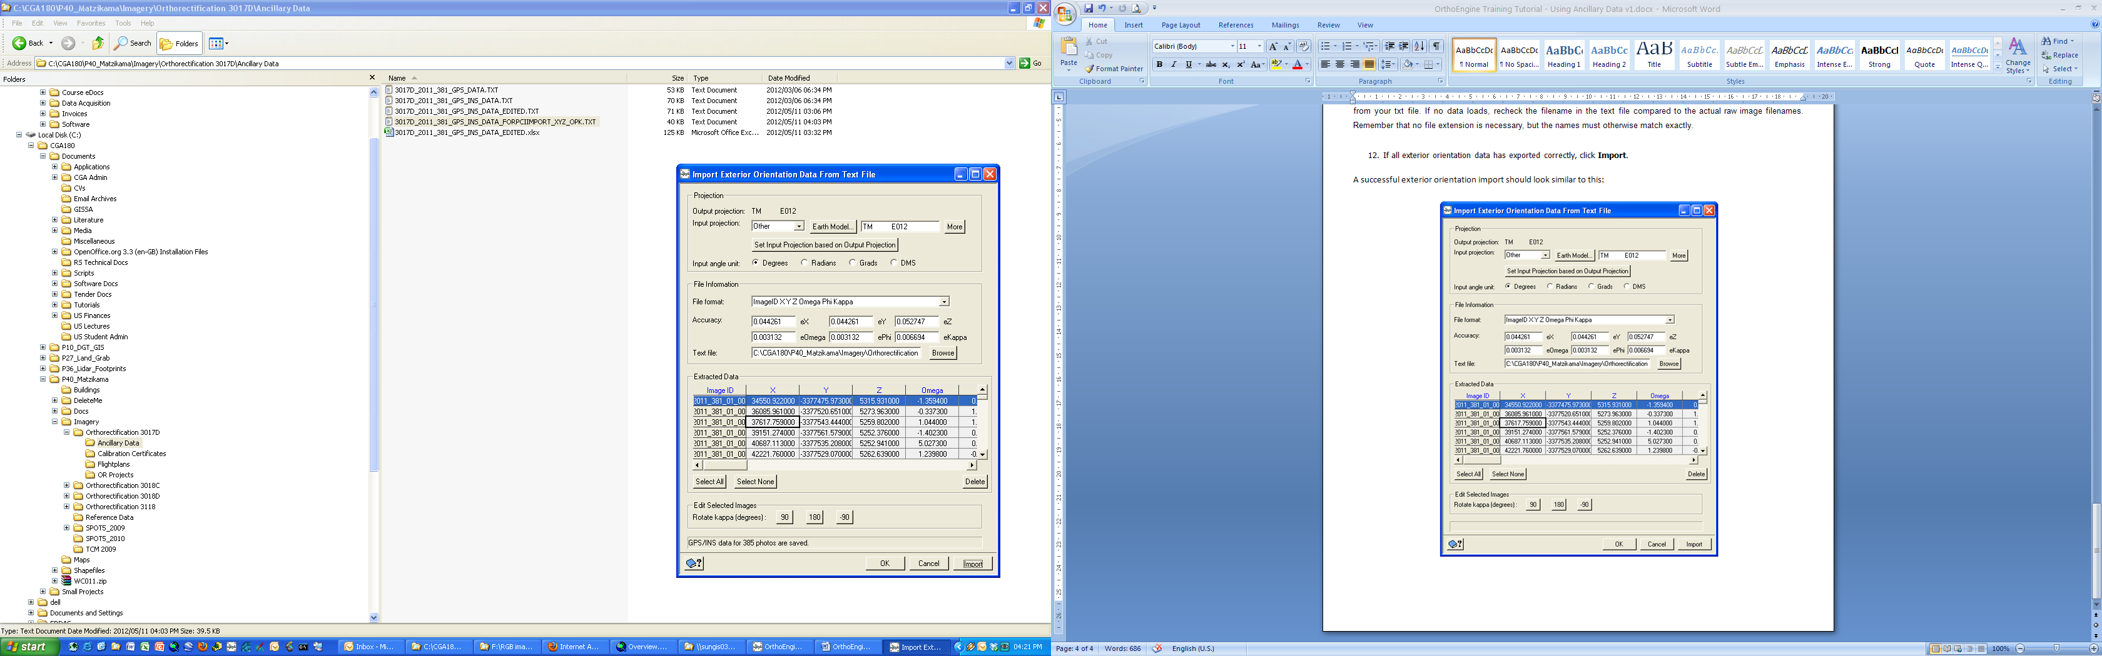

1. Click **OK.**
2. To ensure you are on the right track, change the **Processing step** to **Model Calculations** and click **Compute Model**. You should see this message:

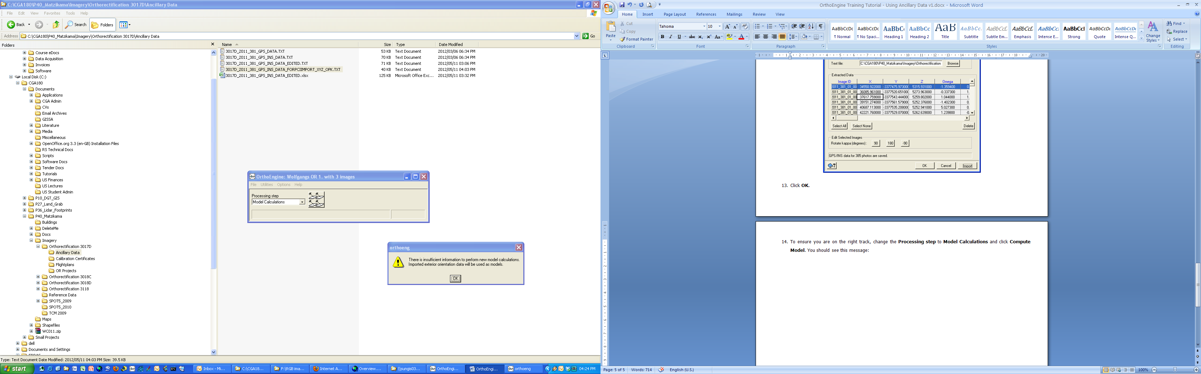

1. Change the **Processing step** to **Ortho Generation** and click **Schedule ortho generation**. Set up the images to process, output folder, input DEM and processing options as you would for any other orthorectification project.
2. Double check the projected coordinates for a couple of your images to make sure they look correct. If they are, click **Generate Orthos**.

**Notes:**

- If the projected coordinates of your aerials read -1000000000 or you get a message saying the DEM does not overlap, there is something wrong with the projection set up of the project (or your DEM is not big enough). Note that it is always better to start a new project if you need to change the projection, rather than removing the images from an existing project, changing the projection and loading new images.

- Projection reference structure differs between ArcGIS and PCI. If projections are causing problems in OrthoEngine, reproject your images in Focus.

- Typical orthorectification times for digital aerials with a 0.5m resolution, 20m DEM and 1024Mb allocated to processing are around 2 minutes per orthoimage.

- Ensure there is enough disk space for your output imagery, each orthorectified aerial can be up to 750Mb. Remember that for OrthoEngine to run optimally you must have at least 15-20Gb of free disk space.